How do I log in to CloudCME®?

Start by reviewing which user type best describes you below:

Returning Faculty Members and External Users that have attended sessions in the past and used the previous portal OR signed in on a paper sign-in sheet at UH or CWRU activities OR the user has forgotten their password

- Go to https://cwru.cloud-cme.com
- Click “Sign In” and “Forgot Your Password?” on the menu bar to reset your password.
- Return to the https://cwru.cloud-cme.com site and Sign in.

New Faculty Members and External Users that have never logged in

- Go to https://cwru.cloud-cme.com
- Click “Sign Up Now” and follow the instructions.
- Return to https://cwru.cloud-cme.com and Sign in.

Faculty Members and External Users that have attended sessions in the past but cannot remember their login information

- Go to https://cwru.cloud-cme.com
- Click “Sign Up Now” and follow the instructions.
- Return to the https://cwru.cloud-cme.com site and Sign in.
- Email medcme@case.edu and ask the staff to perform a merge. Tell them that you had previously used the old system but cannot remember which email address you used so you created a new account and now need them merged.

How do I update my profile?

Sign in with your email address and password. Once signed in, click on the blue MyCME tab:

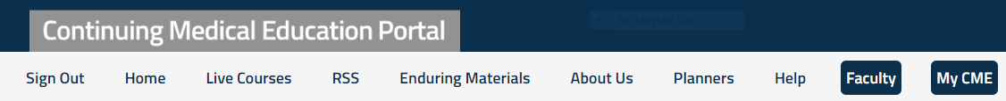
Click the gray “Profile” button and proceed to update your profile as needed:

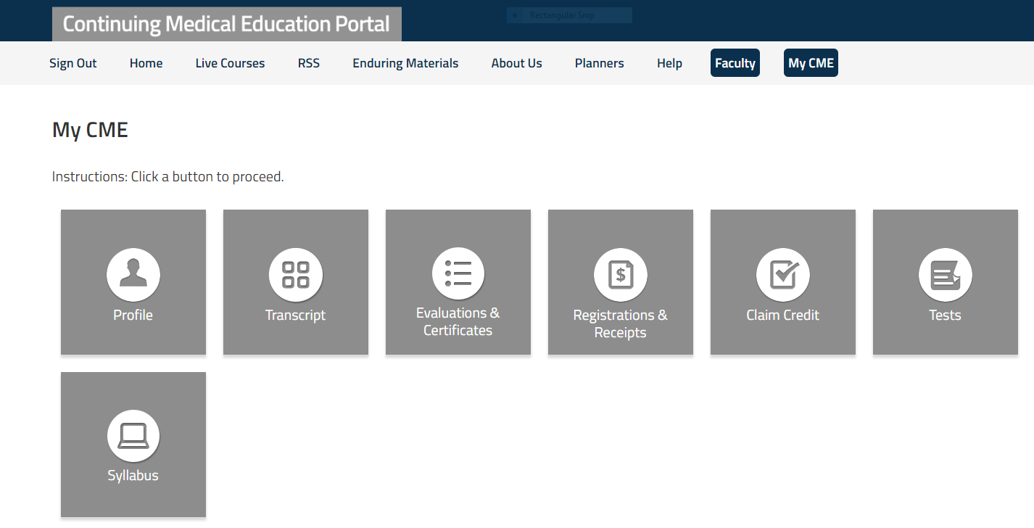

How do I view and/or print my transcript?

You may view and/or print your transcript by logging in, clicking the blue MyCME tab and clicking the gray “Transcript” button.

- You may filter by date and/or credit type.
- To download your transcript and save it in your files or on your desktop, click “Download Transcript”. Open the file and save it or print it.
- To Email your transcript to your email address or another email address, click “Email Transcript”.

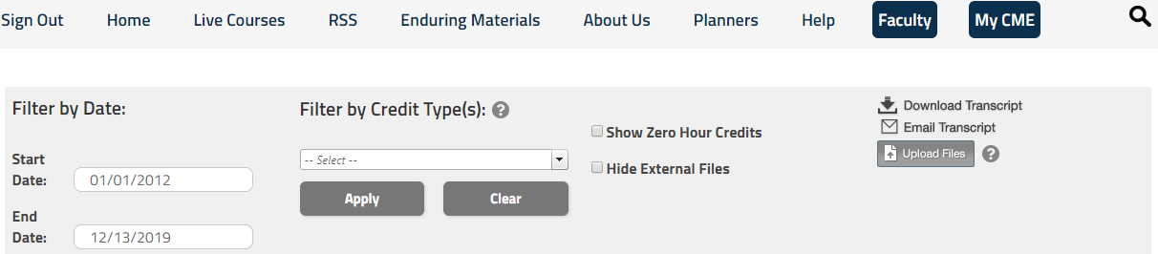

How do I download the CloudCME® app and what is the organization code?

Use the mobile application to claim credits, complete evaluations, access presentation slides, view credit transcripts and more!

- For iPhone/iOS users, visit the Apple App store and search CloudCME® or click HERE
- For Google/Android users, visit the Google Play App store and search CloudCME® or click HERE
- The Organization Code is CWRU.
- You must complete this step PRIOR to trying to claim credit.

Login with the same email and password used for the online CME portal.

I am locked out of the system. What should I do?

After a certain number of failed attempts to login, your account will be locked. CWRU CME staff can assist you with unlocking your account by emailing medcme@case.edu or by calling the main number at 216.983.1239.

How do I record my attendance or claim credit for attending?

You can claim credit by using the CloudCME® App, SMS text message or from your desktop.

Claim Credit by App:

- Log into the mobile app using your Smartphone or cellular device.
- From the menu select “Claim Credit” (you may have to scroll down to find it).
- Enter the ID or the “Event Code” (provided by your session coordinator or administrator) into the Event ID box and complete the remaining questions.
- Enter your digital signature and click “Claim Credit”.

Claim Credit by SMS text: (FLIP PHONE USERS CAN CLAIM CREDIT THIS WAY)

- If this is your first time texting your attendance, you must first pair your mobile number to your CloudCME® account. This step only needs to be completed ONCE. Text your email address (the one you entered in your profile) to 216.208.5442. You will receive a message that looks like the one below, that your phone number has been updated.
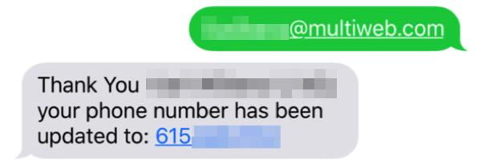
- Enter the Activity ID or Code provided for your activity. You will receive a message verifying your activity attendance has been recorded.

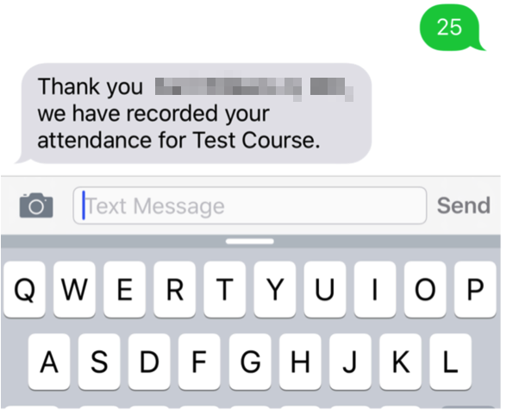
NOTE: If using an iPhone/iOS, you must text using SMS text, NOT iMessage.

- You may only record attendance once per activity. Attempting to record your attendance more than once will result in receipt of the following message:

Claim Credit by desktop:

- Log in to your profile at http://cwru.cloud-cme.com.
- Click the highlighted “MyCME” tab on the top right-hand side of the screen.
- Click “Claim Credit”

- Enter the Activity ID and click “Submit ID”.

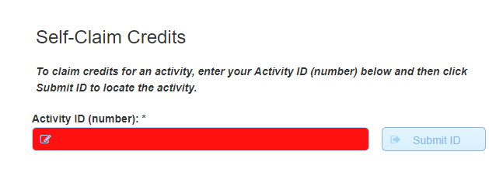
- Complete all of the requested information, attest and submit.

I tried to SMS text my attendance but received an error message, what should I do?

There are a couple of reasons that you may have received an error message. Depending on which error message you receive, you may have to call the office at 216.983.1239.

ERROR MESSAGE | ACTION
User not found in system | You must have an active profile in CloudCME® that is linked to your email address. Follow the steps to pair your phone by clicking HERE.
Attendance cannot be recorded – you can only record XX minutes after the activity has completed | You are attempting to claim credit outside of the allotted time frame. You have 3 days to claim using the App or by SMS text message. You can claim from your desktop for up to 30 days.
Your attendance has already been recorded | You have already claimed credit for this session. No other action required.
Invalid ID | You have entered the wrong Activity Code. Please contact our office at 216.983.1239 or the session coordinator.

Why am I being told to claim credits as a Non-Physician? Will I still receive credit?

Case Western Reserve University School of Medicine is accredited by the Accreditation Council for Continuing Medical Education (ACCME) to provide continuing medical education for physicians. Only physicians are eligible to be awarded AMA PRA Category 1 Credit ™. For the purpose of awarding and claiming AMA PRA credit, the AMA defines physicians as those individuals who have obtained an MD, DO or equivalent medical degree from another country. No other healthcare providers may be awarded AMA PRA Category 1 Credit ™.

Non-Physician attendance credit is provided to non-physicians who participate in activities that are designated for AMA PRA Category 1 Credits ™. The Continuing Medical Education Program provides documentation (transcripts, certificates) that states that the activity was certified for AMA PRA Category 1 Credit ™.

For the purpose of recertification, the American Academy of Nurse Practitioners Certification Board (ANPC) and American Nurses Credentialing Center (ANCC), and the National Commission on Certification of Physician Assistants (NCCPA), accept certificates of participation for educational activities certified for AMA PRA Category 1 Credits ™ issued by organizations accredited by the ACCME.

Learners should check with their state licensing board to ensure it accepts reciprocity with AMA PRA Category 1 Credits ™.

I am past the 3-day cutoff to claim credit for attending an RSS (Grand rounds, Tumor board or Morbidity and Mortality conference, etc.) by SMS text or using the CloudCME® app. Can I still claim credit?

You may still claim credit using your desktop by logging into your profile. Attendees have up to 30 days after the session takes place to claim credit. To claim credit by desktop, follow the instructions HERE.

Those that are claiming credit for Intensive Courses and other Case accredited programming have up to 7-days to claim by SMS or the CloudCME™ app. If you have trouble claiming credit using these methods and are within the correct timeframes, please contact the CME Program at 216.983.1239.

I am presenting at one of your upcoming conferences or sessions. I was told that I have to complete an electronic financial disclosure. I did not receive an email and I do not know where to find it. Can you help?

To assure fair and unbiased presentation of valuable educational materials and to comply with the ACCME Standards for Commercial, the ACCME requires Case Western Reserve University School of Medicine to identify and resolve conflicts of interest for all individuals responsible for the development, management, presentation, and/or evaluation of a CME activity.

In order to fulfill this requirement, the CME Program can only approve a CME activity when all involved individuals have completed a financial disclosure form. You can locate the form by clicking this LINK to the portal. ***Please note, if you do not have an account, you will be prompted to set-up a profile first.

If you still cannot locate the form or have issues creating an account, please complete the Word version of the form located HERE and return the form to the Coordinator of the session in which you are participating. PLEASE DO NOT RETURN THE FORM DIRECTLY TO THE CME PROGRAM OFFICE.

I am seeking re-licensure and need to send proof of my participation in CME activities. How can I get my certificates of attendance?

Any person that attends CWRU CME activities have access to the CME portal and can view and print their transcripts. You may also email your transcripts directly. Follow the instructions to obtain your transcript by clicking HERE. *Please note: You may have to update your profile to access the portal. If you log in and do not see a transcript, or notice missing information, you may have more than one account in the system. Email the CME Program team medcme@case.edu and ask for the accounts to be merged. Please allow up to 24 hours for a response.

I registered and paid to attend one of your courses online but did not receive a receipt. How can I print a receipt for proof of payment?

Receipts are available for printing by logging into your profile and following the instructions listed HERE. If you cannot find the receipt or have trouble accessing the information, contact the CME Program team at 216.983.1239 for assistance.

I would like to attend one of your activities. How do I register?

You may register for any activity by going to the CWRU CME portal at https://cwru.cloud-cme.com clicking “Live Courses” or “Enduring Materials” and clicking the “Register” button under the activity you plan to attend. RSS’s do not require registration to attend. Please note that you must have a profile in the system to register. If you do not have a profile, you will be prompted to create one.

Links to useful information/handouts for users:
User Manual/Create an Account
Claiming Credit by SMS Text
Claiming Credit by Desktop
Claiming Credit by using the CloudCME App
Access your Transcripts

