**Instructions for Users to Complete Evaluation and Claim Credit**

**Step 1:** Go to evaluation link - be sure to **record the credit claim number at the end of the evaluation.**

**Step 2:** Go to <https://cwru.cloud-cme.com>.

**Step 3:** Click "Sign In" on the top left, and sign in using your email address and password.

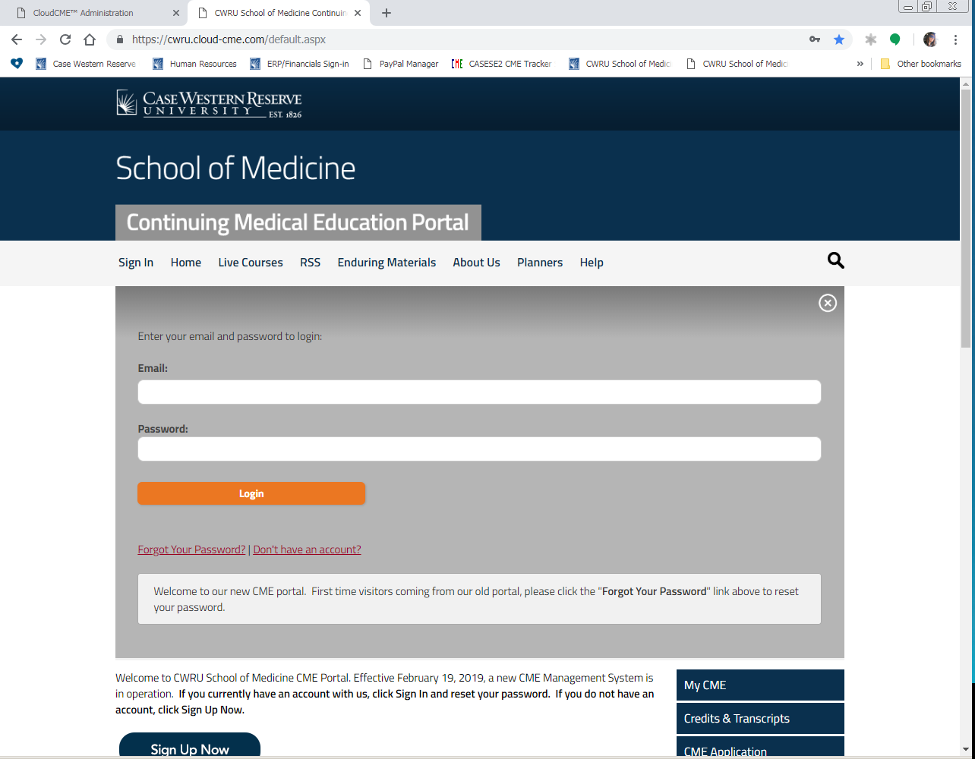

**Step 4:** Click the "My CME" button on the top right-hand side of the screen.



**Step 5:** Click the "Claim Credit" button.

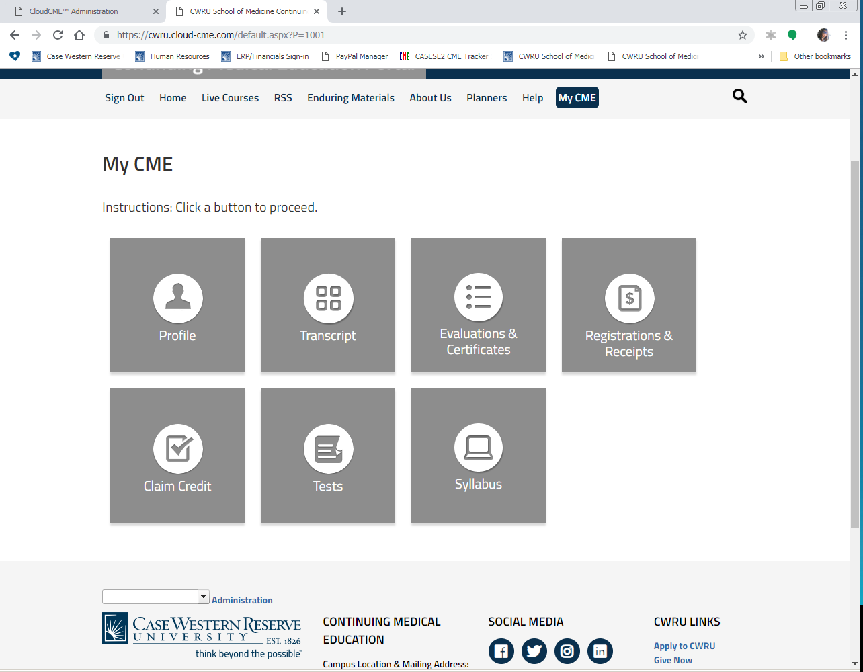

**Step 5:** Enter the Event ID you recorded after completing your evaluation and click the “Submit ID” button.



**Step 6:** Complete any additional questions or fields.

**Step 7:** Once your credits are recorded, you will then be taken back to My CME. Go to

Evaluations & Certificates. Your certificate will be there and available for printing.

